Fundamentals Of Data Structure And Algorithms

Github Link: https://github.com/rudraaaajoshi/FDSA_BATCH_A/tree/main/Practical-2
Practical-2.1
Difficulty:
The main difficulty was understanding the difference between iterative and recursive searching. I had to understand how the iterative method checks elements using a loop and how the recursive method continues searching by calling the function again.
Error:
Initially, I was confused about how to stop the recursive function after finding the required license plate. I also had to handle the situation correctly when the target plate was not present in the list.
Solution:
I first used a loop to check the license plates one by one from the beginning. Then, I implemented the recursive approach where the function checks one element and calls itself for the next position until the target is found or the list ends.
Outcome:
I successfully implemented both iterative and recursive linear search. I understood that linear search can find the first occurrence of the target and that recursion can perform the same search without using a loop.
Code Link:
https://github.com/rudraaaajoshi/FDSA_BATCH_A/blob/main/Practical-2/pr%202.1.c
Output:
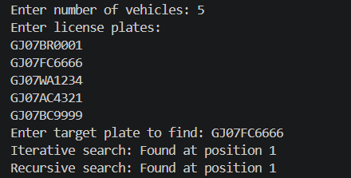
Key Questions:
Problem-1 If the target plate appears near the end of a very long list, your solution still checks every plate before it. Can you think of any property the input would need to have for you to skip checking some plates entirely? What does Problem 2.2 tell you about this?
Answer:
If the list of plates is sorted in some known order, we may be able to skip checking many plates. For example, if the plates are sorted by their number, we can use Binary Search instead of checking every plate one by one. Binary Search checks the middle element and eliminates half of the remaining list each time. Problem 2.2 tells us about the importance of the input being sorted. If the data has a useful order, we can use that property to make the search faster. if the input list is sorted, we can skip checking some plates by using Binary Search. We can eliminate half of the remaining elements after each comparison. Problem 2.2 shows that sorted data can make searching much more efficient.

Practical-2.2
Difficulty:
The main difficulty was understanding how binary search reduces the searching area after every comparison. I had to carefully understand when the search should continue toward the left side and when it should move toward the right side.
Error:
Initially, I faced difficulty in updating the low and high positions correctly. If these positions are not updated properly, the program may give an incorrect result or continue searching unnecessarily.
Solution:
I used the middle element to compare with the target book code. If the target was smaller, I searched the left half, and if it was larger, I searched the right half. I implemented this process using both iterative and recursive approaches.
Outcome:
I successfully implemented binary search using both methods and learned that it is faster than linear search because it removes half of the search area after each comparison. I also understood that the input list must be sorted for binary search to work correctly.
Code Link:
https://github.com/rudraaaajoshi/FDSA_BATCH_A/blob/main/Practical-2/pr%202.2.c
Output:
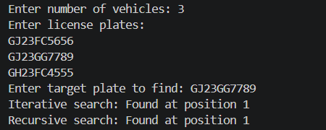
KEY QUESTION:
Problem-2
What is the consequence of applying your solution to a list that is not sorted? Would it always give a wrong answer, or only sometimes? Explain your reasoning without running any example.
Answer:
If a searching algorithm assumes that the list is sorted, using it on an unsorted list can give a wrong answer. The list must be sorted first, or we should use a searching method that does not require sorted data, such as Linear Search.

